Sahil Saini Salaria
Reg No. 180905048
Roll No. 11 C

Solved

#include<stdio.h>
#include<mpi.h>

int main(int argc, char *argv[])
{
int rank,size,ele;

int arr[100],res[100];
MPI_Init(&argc,&argv);

MPI_Comm_rank(MPI_COMM_WORLD,&rank);
MPI_Comm_size(MPI_COMM_WORLD,&size);

if(rank==0)
{
printf("Enter the %d numbers:\n",size);
for (int i = 0; i < size; i++)
{
scanf("%d",&arr[i]);
}
}

MPI_Scatter(arr,1,MPI_INT,&ele,1,MPI_INT,0,MPI_COMM_WORLD);

ele=ele*ele;

MPI_Gather(&ele,1,MPI_INT,res,1,MPI_INT,0,MPI_COMM_WORLD);

if(rank==0)
{
for (int i = 0; i < size; i++)
{
printf("Rank %d , square of %d is: %d\n",i,arr[i],res[i]);
}

}
MPI_Finalize();

return 0;

}

// mpicc solved.c -lm -o solved && mpirun -np 4 ./solved

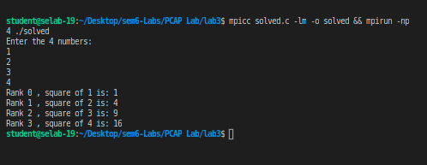

Exercise

Q1

#include<stdio.h>
#include<mpi.h>

int main(int argc, char *argv[])
{
int rank,size,ele;

int arr[100],res[100];
MPI_Init(&argc,&argv);

MPI_Comm_rank(MPI_COMM_WORLD,&rank);
MPI_Comm_size(MPI_COMM_WORLD,&size);

if(rank==0)
{
printf("Enter the %d numbers:\n",size);
for (int i = 0; i < size; i++)
{
scanf("%d",&arr[i]);
}
}

MPI_Scatter(arr,1,MPI_INT,&ele,1,MPI_INT,0,MPI_COMM_WORLD);

int fact=1;

for (int i = 1; i <=ele; i++)
{
fact=fact*i;
}

MPI_Gather(&fact,1,MPI_INT,res,1,MPI_INT,0,MPI_COMM_WORLD);

if(rank==0)
{
long long int result=0;
for (int i = 0; i < size; i++)
{
printf("Rank %d, factorial of %d id : %d\n",i,arr[i],res[i]);
result=result+res[i];
}

printf("Sum of all factorials is :%lld",result);

}
MPI_Finalize();

return 0;

}

// mpicc prog1.c -lm -o prog1 && mpirun -np 4 ./prog1

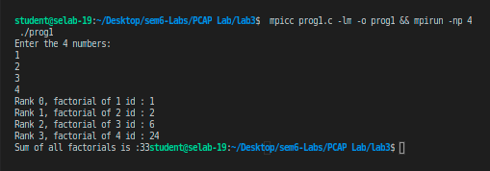

Q2

#include<stdio.h>
#include<mpi.h>

int main(int argc, char *argv[])
{
int rank,size,M;

int arr[1000],ele[100];
float res[1000];

float avg=0;

MPI_Init(&argc,&argv);

MPI_Comm_rank(MPI_COMM_WORLD,&rank);
MPI_Comm_size(MPI_COMM_WORLD,&size);

if(rank==0)
{
printf("Enter value of M:\n");
scanf("%d",&M);

printf("Enter the %d numbers:\n",size*M);
for (int i = 0; i < size*M; i++)
{
scanf("%d",&arr[i]);
}
}
MPI_Bcast(&M,1,MPI_INT,0,MPI_COMM_WORLD);
MPI_Scatter(arr,M,MPI_INT,ele,M,MPI_INT,0,MPI_COMM_WORLD);

for (int i = 0; i <M; i++)
{
avg=avg+ele[i];
}
avg=avg/M;

MPI_Gather(&avg,1,MPI_FLOAT,res,1,MPI_FLOAT,0,MPI_COMM_WORLD);

if(rank==0)
{
float final_avg=0;
for (int i = 0; i < size; i++)
{
printf("Rank %d, avg is: %f\n",i,res[i]);
final_avg=final_avg+res[i];
}

final_avg=final_avg/M;

printf("Average is :%f",final_avg);

}
MPI_Finalize();

return 0;

}

// mpicc prog2.c -lm -o prog2 && mpirun -np 4 ./prog2

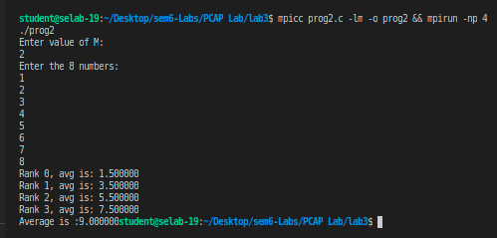

Q3

#include <stdio.h>
#include <mpi.h>
#include <string.h>

int isConsonant(char ch)
{
return !(ch == 'a' || ch == 'e' || ch == 'i' || ch == 'o' || ch == 'u' || ch == 'A' || ch == 'E' || ch == 'I' || ch == 'O' || ch == 'U');
}

int main(int argc, char *argv[])
{
int rank, size;

int slen;

int send_size_per_process = 0;

char str[1000], ele[1000];

int res[100];

int len = 0;

MPI_Init(&argc, &argv);

MPI_Comm_rank(MPI_COMM_WORLD, &rank);
MPI_Comm_size(MPI_COMM_WORLD, &size);

if (rank == 0)
{
printf("Enter the string\n");
scanf("%s", str);

len = strlen(str);

send_size_per_process = (len - (len % size)) / size;
}

MPI_Bcast(&send_size_per_process, 1, MPI_INT, 0, MPI_COMM_WORLD);

MPI_Scatter(str, send_size_per_process, MPI_CHAR, ele, send_size_per_process, MPI_CHAR, 0, MPI_COMM_WORLD);

int tot_per_process = 0;

for (int i = 0; i < send_size_per_process; i++)
{
if (isConsonant(ele[i]))
tot_per_process++;
}

MPI_Gather(&tot_per_process, 1, MPI_INT, res, 1, MPI_INT, 0, MPI_COMM_WORLD);

if (rank == 0)
{
int total = 0;
for (int i = 0; i < size; i++)
{
printf("Rank %d, %d non-vowels\n", i, res[i]);
total=total+res[i];
}

for (int i = size * send_size_per_process; i < len; i++)
{
if (isConsonant(str[i]))
{
total++;
}
}

printf("Total non-vowels: %d ", total);
}
MPI_Finalize();

return 0;
}

// mpicc prog3.c -lm -o prog3 && mpirun -np 4 ./prog3

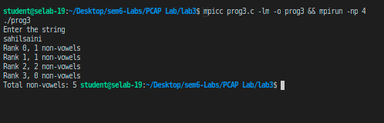

Q4

#include <stdio.h>
#include <mpi.h>
#include <string.h>

int isConsonant(char ch)
{
return !(ch == 'a' || ch == 'e' || ch == 'i' || ch == 'o' || ch == 'u' || ch == 'A' || ch == 'E' || ch == 'I' || ch == 'O' || ch == 'U');
}

int main(int argc, char *argv[])
{
int rank, size;
int slen;
int send_size_per_process = 0;
char str1[1000], str2[1000], ele1[1000], ele2[1000];
char res[10000];
int len = 0;

MPI_Init(&argc, &argv);

MPI_Comm_rank(MPI_COMM_WORLD, &rank);
MPI_Comm_size(MPI_COMM_WORLD, &size);

if (rank == 0)
{
printf("Enter the string 1 : \n");
scanf("%s", str1);

len = strlen(str1);

printf("Enter the string 2 of size %d: \n", len);
scanf("%s", str2);

send_size_per_process = (len - (len % size)) / size;
}

MPI_Bcast(&send_size_per_process, 1, MPI_INT, 0, MPI_COMM_WORLD);
MPI_Scatter(str1, send_size_per_process, MPI_CHAR, ele1, send_size_per_process, MPI_CHAR, 0, MPI_COMM_WORLD);
MPI_Scatter(str2, send_size_per_process, MPI_CHAR, ele2, send_size_per_process, MPI_CHAR, 0, MPI_COMM_WORLD);

char per_process_arr[1000];
int count = 0;

for (int i = 0; i < send_size_per_process; i++)
{

per_process_arr[count++] = ele1[i];
per_process_arr[count++] = ele2[i];
}

MPI_Gather(per_process_arr, count, MPI_CHAR, res, count, MPI_CHAR, 0, MPI_COMM_WORLD);

if (rank == 0)
{
count = strlen(res);

for (int i = count / 2; i < len; i++)
{
res[count++] = str1[i];
res[count++] = str2[i];
}
printf("Output string: \n");
puts(res);
}
MPI_Finalize();

return 0;
}

// mpicc prog4.c -lm -o prog4 && mpirun -np 4 ./prog4

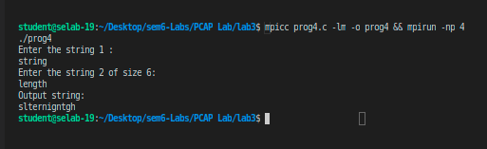

Additionals

Additional1

#include <stdio.h>
#include <mpi.h>

int main(int argc, char *argv[])
{
int rank, size, M;

int arr[1000], ele[1000];
int res[1000];

MPI_Init(&argc, &argv);

MPI_Comm_rank(MPI_COMM_WORLD, &rank);
MPI_Comm_size(MPI_COMM_WORLD, &size);

if (rank == 0)
{
printf("Enter value of M:\n");
scanf("%d", &M);

printf("Enter the %d numbers:\n", size * M);
for (int i = 0; i < size * M; i++)
{
scanf("%d", &arr[i]);
}
}
MPI_Bcast(&M, 1, MPI_INT, 0, MPI_COMM_WORLD);
MPI_Scatter(arr, M, MPI_INT, ele, M, MPI_INT, 0, MPI_COMM_WORLD);

if (rank % 2 == 0)
{
for (int i = 0; i < M; i++)
{
ele[i] = ele[i] * ele[i];
}
}
else
{
for (int i = 0; i < M; i++)
{
ele[i] = ele[i] * ele[i] * ele[i];
}
}

MPI_Gather(ele, M, MPI_INT, res, M, MPI_INT, 0, MPI_COMM_WORLD);

if (rank == 0)
{
for (int i = 0; i < size*M; i++)
{
printf("Rank %d, operation on %d gives: %d\n", i,arr[i], res[i]);
}
}
MPI_Finalize();

return 0;
}

// mpicc additional1.c -lm -o additional1 && mpirun -np 4 ./additional1

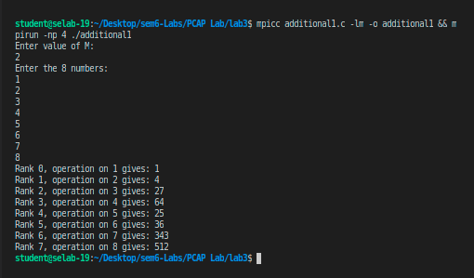

Additional2

#include <stdio.h>
#include <mpi.h>

int main(int argc, char *argv[])
{
int rank, size, M;

int arr[1000], ele[1000],res[1000];

int total_e, total_o;

MPI_Init(&argc, &argv);

MPI_Comm_rank(MPI_COMM_WORLD, &rank);
MPI_Comm_size(MPI_COMM_WORLD, &size);

if (rank == 0)
{
printf("Enter value of M:\n");
scanf("%d", &M);

printf("Enter the %d numbers:\n", size * M);
for (int i = 0; i < size * M; i++)
{
scanf("%d", &arr[i]);
}
}
MPI_Bcast(&M, 1, MPI_INT, 0, MPI_COMM_WORLD);
MPI_Scatter(arr, M, MPI_INT, ele, M, MPI_INT, 0, MPI_COMM_WORLD);

int e_count = 0;
int o_count = 0;
for (int i = 0; i < M; i++)
{
if (ele[i] % 2 == 0)
ele[i] = 1, e_count++;
else
ele[i] = 0, o_count++;
}

MPI_Gather(ele, M, MPI_INT, res, M, MPI_INT, 0, MPI_COMM_WORLD);
MPI_Reduce(&e_count,&total_e,1 ,MPI_INT, MPI_SUM,0,MPI_COMM_WORLD);
MPI_Reduce(&o_count,&total_o,1 ,MPI_INT, MPI_SUM,0,MPI_COMM_WORLD);

if (rank == 0)
{
for (int i = 0; i < size * M; i++)
{
printf("Rank %d, operation on %d gives: %d\n", i, arr[i], res[i]);
}

printf("Taotal even numbers in array are:%d \n",total_e);
printf("Taotal odd numbers in array are:%d \n",total_o);

}
MPI_Finalize();

return 0;
}

// https://cvw.cac.cornell.edu/mpicc/scan

// mpicc additional2.c -lm -o additional2 && mpirun -np 4 ./additional2

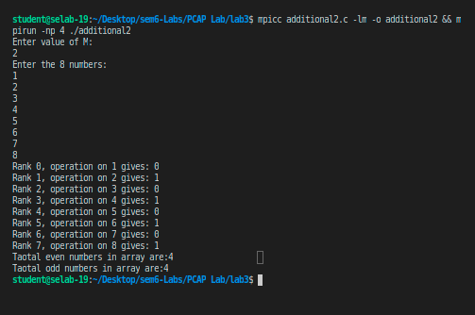

//////////////////////////////////////////////////ENDS////////////////////////////////////////////////////////////////

